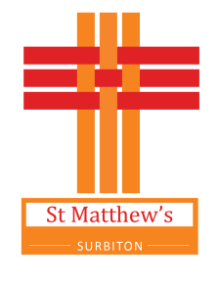

Location warning notice -
live-streaming taking place here

Please be advised that our regular church services are now live-streamed to Facebook and our YouTube Channel
(‘StMatthewsChurchSurbiton’).

There is a camera at the back of church and one on each side towards the front. If you are sitting in the front three pews you may be quite obvious. If you sit in the other pews your image from behind may be seen but your face would only be visible if you turn round.

When anyone comes up to the front (other than to receive Holy Communion) you may be clearly visible. This includes the children being on the platform for the Action Song, at the end of the service or at other times. The live stream does not include images of people coming forward to receive Holy Communion.

If you do not wish to appear in any images (or you have that concern for those for whom you are responsible) please inform a Churchwarden or welcomer.

By attending our services, you are presumed to have given consent to these arrangements.

Thank You

